**Class Name and Section:** ISEM-501-50

**Student Name** Bhavneet Soni

**Date** 21 – June – 2018

**Assignment** Essay – Chapter 3 Hardware Question

Hardware Topic for Review: Change in Computer architecture in recent years. Has this architecture changed in 10 years? Where have the most advances been made? What is limiting advances in each component?

The basic architecture of a modern-day computer has been similar to older computers, any machine (computer) has mainly the following sections

1. Interactive section i.e. an input and output section to give commands and get the results from the computer.
2. Functional section i.e. the operational part that executes the desired functions (computations and processing).

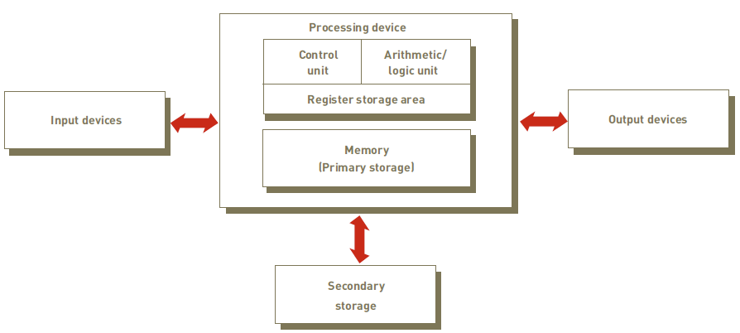

Input and output devices have been not changed much in past 10 years however we have seen a great reduction in prices and quality of Monitors and pointing devices. Such as Ultra high definition monitors and massive availability of the touch screens so much so that touch screens have become the norm and any device with a graphic interface has touch factor associated with it. Tablets and smartphones have gone away with keyboards and pointing devices. Another change we have been seeing more so in recent times past couple of years is use of voice commands for input and output, e.g. companies like amazon and google are providing voice activated assistant bots (Echo, Pixel Home) that have no screens and keyboards at all and are totally voice interaction based. In past couple of years, we have also seen an increase in 3d printing which has totally changed how we use to present the results, earlier a CAD professional would have to generate various drawings and physically produce a prototype to present it which was cost inhibitive, but with 3D printing we can get the prototype printed immediately in the office.

When the book was written mainly single core processors were the norm and prevalent technology, however in today’s world we see about 8 – 16 cores as normal. These have presented us with a new paradigm of parallel processing. It has made software engineers to think in terms of how to achieve maximum output from the computer resources by splitting the program over multiple cores and threads. With the advent of big data it has gone a step further we now have distributed file system technologies in which the processing and the data stored is distributed over hundreds and thousands of machines across the multiple racks, buildings or geographical regions. Also with the internet speeds and bandwidth availability increasing tremendously over the past few years the cloud computing has matured into something every one use these days, from storing your backup files to using real time programs on the cloud so that you don’t have to buy or own the software or hardware required to do the data processing. A user just can buy some time on the cloud to do their analysis or computations get the results back. For example one can use Amazons cloud services, Input and output terminals are on the user end but the whole computing happens on computer system on the other end of the world.

Although the processing power has increased based on the Mores law, doubling the transistor density every 18 -24 months’, bottlenecks have mainly been on the memory side. There has been increase in the CPU memories and caches giving a faster data access to processor but these have not been able to keep up with the advances in the processing units’ performance. We have seen recent advances in technology with the advent of programmable storage and 3D memory. 3D packaged memory is just two or more RAM chips stacked on top of each other providing us increased memory capacity and also provides possibility of integrating compute logic directly with one or more memory layers, thereby allowing for possibility of near-memory computations. Research has progressed in the use of Processing In Memory (PIM) over last few years taking us closer to fully-programmable memory architectures. Once achieved commercially application developers can run custom code directly in memory there by circumventing the use of a separate CPU altogether.

Software Topic for Review: Programming Languages and future predictions.

Update Table 4.9, and give examples of programming languages. What is your prediction for the next 5-10 years?

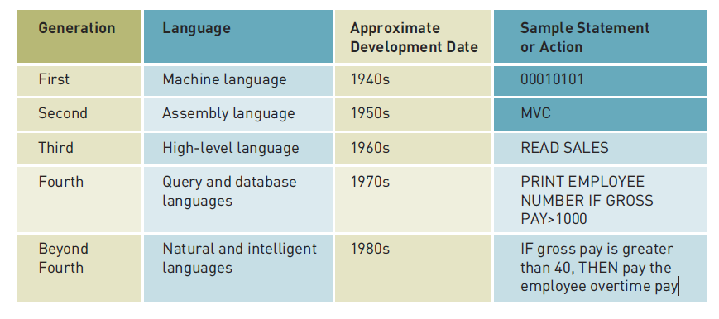

Natural languages are as close to human language as it gets and most of the programing languages today reading code is easy as they have natural language syntax such as conditional statements, looping statements etc. Under natural and intelligent languages there are various specifications on the sort of design patterns these use such as structured vs object oriented. Although the author discussed other languages such as Object oriented and Visual oriented programming languages in the text they were not mentioned in the table. To complete this table I will add Object Oriented languages that have been prevalent from late 1990s (Java, C++) and still derive most of present days’ software design pattern.

With Big data coming into picture and every application and industry want to move to the cloud based computing another generation of programing language that has come up recently is Distributed file system query languages such as PIG, Hive etc that can access data resources saved on different computers in a network. Programmers have to think about networking and distributive nature of these languages to be able to leverage the modern day computing architecture.

# References

*Heterogeneous Computers* . (n.d.). Retrieved from https://scs.senecac.on.ca/~gpu610/pages/content/intro.html

*Information Technology Concept.* (n.d.).

ISAAC, M. (2016, Aug 9). Facebook Blocks Ad Blockers, but It Strives to Make Ads More Relevant. *The New York Times*.